Project Design Phase-II
Data Flow Diagram & User Stories
Date | September 2026
Project Name | ServiceNow-Based Employee Laptop Request Application
Data Flow Diagrams:
A Data Flow Diagram (DFD) is a traditional visual representation of the information flows within a system. It shows how data enters and leaves the system, how requests and approvals are processed, and where information is stored.
Example: (Simplified)
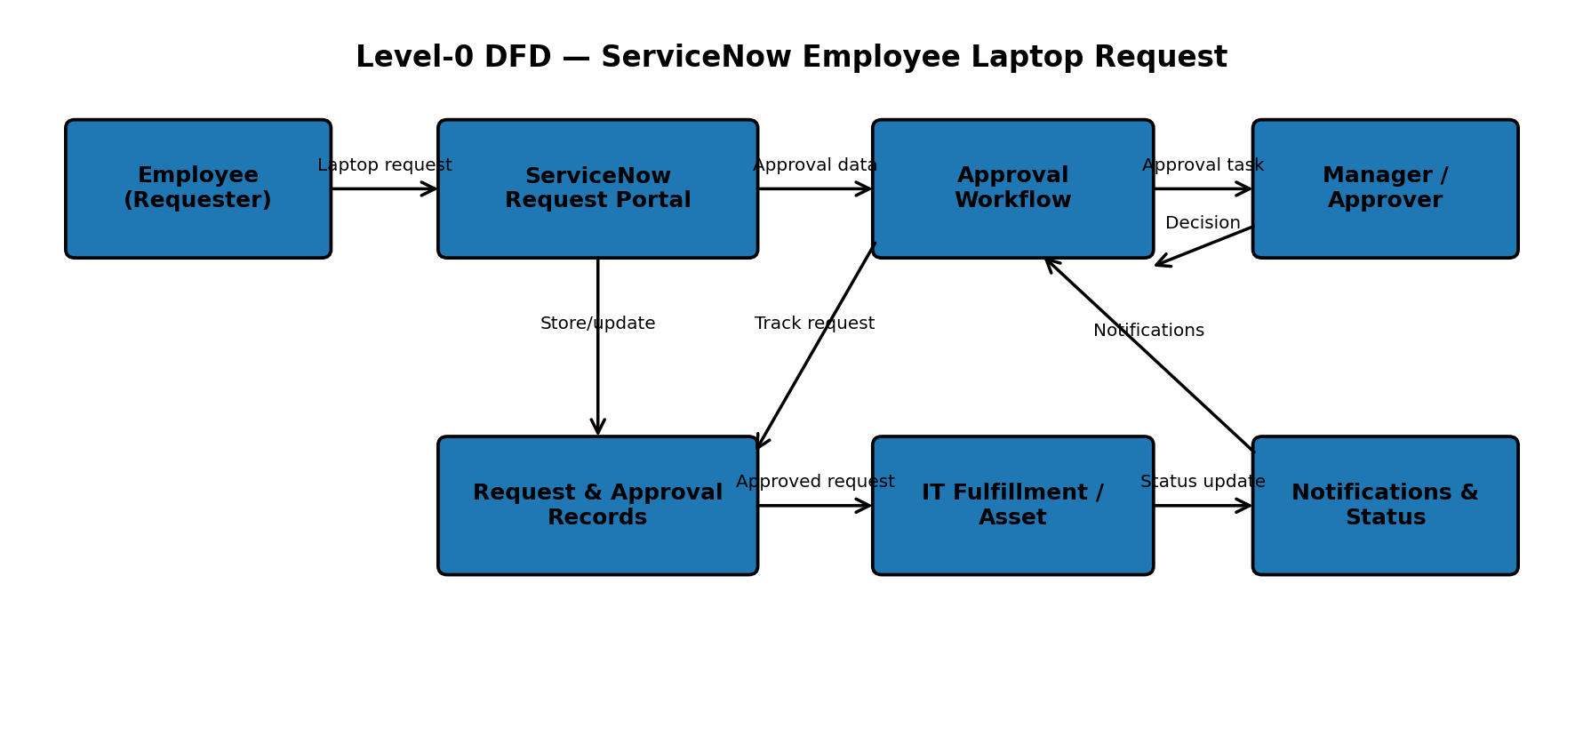
Project data flow:
1. Employee submits a laptop request with required specifications and business justification.
2. ServiceNow validates the request and stores request details.
3. Approval workflow routes the request to the manager/authorized approver.
4. Approval or rejection updates the request status and triggers notifications.
5. Approved requests are handled by IT for asset availability, assignment and delivery tracking.

User Stories:
Use the below template to list the user stories for the product.
User Type | Functional Requirement (Epic) | User Story Number | User Story / Task | Acceptance criteria | Priority | Release
Employee | Laptop Request | USN-1 | As an employee, I can submit a laptop request by selecting the required laptop model/configuration and providing business justification. | Request is submitted successfully with all mandatory details. | High | Sprint-1
Employee | Laptop Request | USN-2 | As an employee, I can view the status of my laptop request after submission. | Current request status is visible in My Requests. | High | Sprint-1
Employee | Tracking & Notifications | USN-3 | As an employee, I can receive notifications when my request is submitted, approved, rejected or updated. | Notification is generated for each relevant status change. | High | Sprint-1
Manager / Approver | Approval Management | USN-4 | As an approver, I can review laptop request details and approve or reject the request with comments. | Approval decision and comments are recorded against the request. | High | Sprint-1
IT Support | Fulfillment | USN-5 | As an IT user, I can check asset availability and assign an available laptop to the employee. | Asset assignment is recorded and linked to the request. | High | Sprint-2
IT Support | Fulfillment | USN-6 | As an IT user, I can update delivery and handover status for an approved laptop request. | Delivery/handover status is updated and visible to the employee. | Medium | Sprint-2
Administrator | Security & Access | USN-7 | As an administrator, I can control access to request data based on user roles and groups. | Only authorized roles can view or update protected data. | High | Sprint-2
IT Manager | Reporting | USN-8 | As an IT manager, I can view request, approval and fulfillment reports. | Reports display accurate request and processing information. | Medium | Sprint-3
Employee | Request History | USN-9 | As an employee, I can view my previous laptop requests and their approval history. | Request history and relevant status details are available. | Medium | Sprint-3
IT Support | Validation | USN-10 | As an IT user, I can validate request information before fulfillment. | Incomplete or invalid requests are flagged before fulfillment. | Medium | Sprint-2
Key project users: Employee (Requester), Manager/Approver, IT Support/Fulfillment Team, and Administrator. These roles participate in request submission, approval, tracking, fulfillment, security and reporting.

